|  |
| --- |
| **Ex. No: 01 Develop an application that uses GUI components, Font andx Colors**  **Date:** |

**Aim:**

To develop a Simple Android Application that uses GUI components, Font and Colors.

**Procedure:**

**Creating a New project:**

∙ Open Android Studio and then click on **File -> New -> New project**.

∙ Then type the Application name as **“**

**″**and click Next.

∙ Then **select the Minimum SDK** as shown below and click Next.

∙ Then select the **Empty Activity** and click Next.

∙ Finally click **Finish**.

∙ It will take some time to build and load the project.

∙ After completion it will look as given below.

**Designing layout for the Android Application:**

∙ Click on **app -> res -> layout -> activity_main.xml**.

∙ Now click on Text as shown below.

∙ Then delete the code which is there and type the code as given below.

**Code for Activity_main.xml:**

<?xml version="1.0" encoding="utf-8"?>

<LinearLayout xmlns:android="http://schemas.android.com/apk/res/android" android:orientation="vertical"

android:layout_width="match_parent"

android:layout_height="match_parent">

<TextView

android:id="@+id/textView"

android:layout_width="match_parent"

android:layout_height="wrap_content"

android:layout_margin="30dp"

android:gravity="center"

android:text="Hello World!"

android:textSize="25sp"

android:textStyle="bold" />

<Button

android:id="@+id/button1"

android:layout_width="match_parent"

android:layout_height="wrap_content"

android:layout_margin="20dp"

android:gravity="center"

android:text="Change font size"

android:textSize="25sp" />

<Button

android:id="@+id/button2"

android:layout_width="match_parent"

android:layout_height="wrap_content"

android:layout_margin="20dp"

android:gravity="center"

android:text="Change color"

android:textSize="25sp" />

</LinearLayout>

∙ Now click on Design and your application will look as given below.

∙ So now the designing part is completed.

**Java Coding for the Android Application:**

∙ Click on **app -> java -> com.example.exno1 -> MainActivity**.

∙ Then delete the code which is there and type the code as given below. **Code for MainActivity.java:**

package com.example.exno1;

import android.graphics.Color;

//import android.support.v7.app.AppCompatActivity;

import android.os.Bundle;

import android.view.View;

import android.widget.Button;

import android.widget.TextView;

import androidx.appcompat.app.AppCompatActivity;

public class MainActivity extends AppCompatActivity

{

int ch=1;

float font=30;

@Override

protected void onCreate(Bundle savedInstanceState) {

super.onCreate(savedInstanceState);

setContentView(R.layout.activity_main);

final TextView t= (TextView) findViewById(R.id.textView); Button b1= (Button) findViewById(R.id.button1); b1.setOnClickListener(new View.OnClickListener() { @Override

public void onClick(View v) {

t.setTextSize(font);

font = font + 5;

if (font == 50)

font = 30;

}

});

Button b2= (Button) findViewById(R.id.button2); b2.setOnClickListener(new View.OnClickListener() { @Override

public void onClick(View v) {

switch (ch) {

case 1:

t.setTextColor(Color.RED);

break;

case 2:

t.setTextColor(Color.GREEN);

break;

case 3:

t.setTextColor(Color.BLUE);

break;

case 4:

t.setTextColor(Color.CYAN);

break;

case 5:

t.setTextColor(Color.YELLOW);

break;

case 6:

t.setTextColor(Color.MAGENTA);

break;

}

ch++;

if (ch == 7)

ch = 1;

}

});

}

}

**Output:**

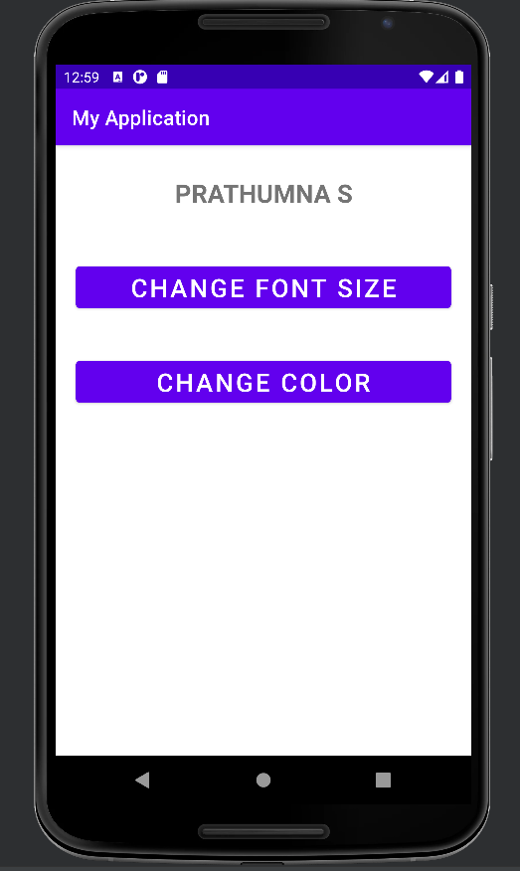

**Result:**

Thus a Simple Android Application that uses GUI components, Font and Colours is developed and executed successfully.